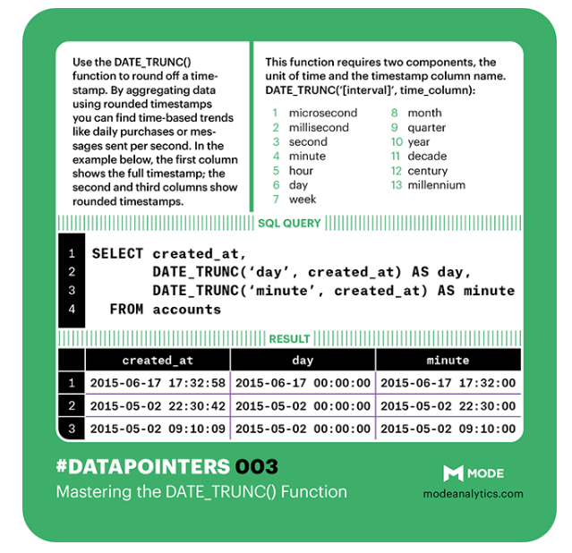

**DATE_TRUNC**(‘[interval]’, time_column)

* microsecond
* millisecond
* second
* minute
* hour
* day
* week
* month
* quarter
* year
* decade
* century
* millenium

DATE_TRUNC() is particularly useful when you want to aggregate information over an interval of time.

select date_trunc('day',occurred_at),count(user_id)

FROM benn.fake_fact_events

where event_name='complete_signup'

and occurred_at >='2014-03-10'

and occurred_at <='2014-05-26'

group by 1

order by 1 desc

